**yANALYSIS OF THE TEST RUN BY LIGHT HOUSE ON 5 WEBPAGES**

1. **FOR NAIRALANG**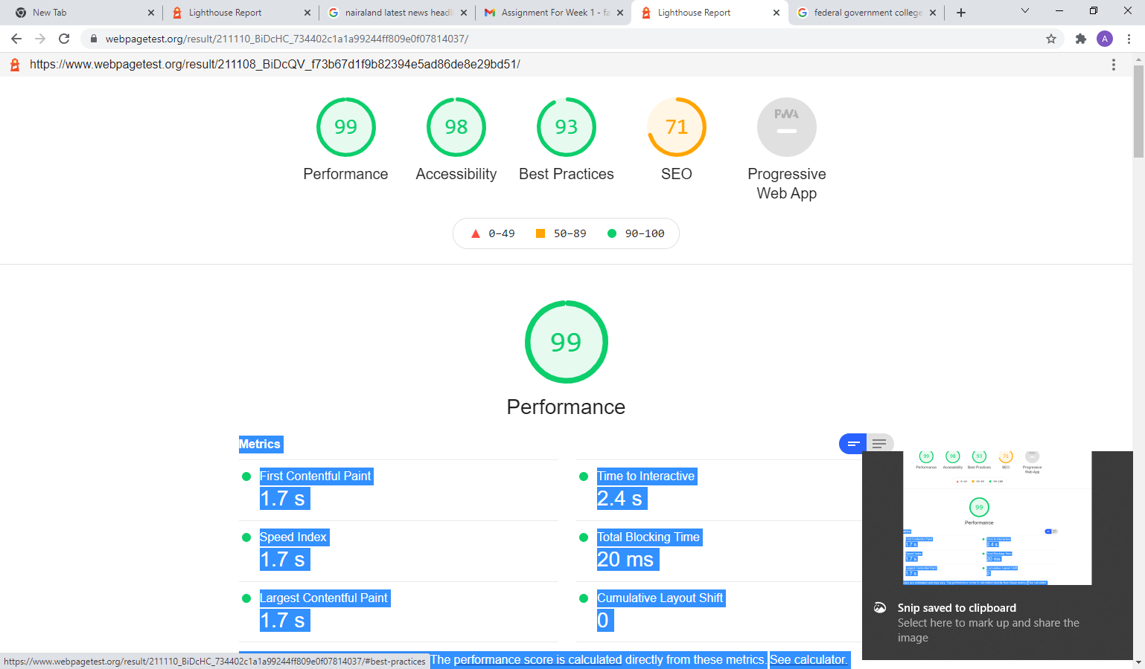

**DIAGNOSTICS ON NAIRALAND**

**Webpage have large files of CSS AND JAVASCRIPT which could slow down performance on the webpage**

**Webpage have low resolution images which may trigger low performance and accessiblity on the webpage**

**WEBPAGE TEST RUN FOR PIGGY BANK**

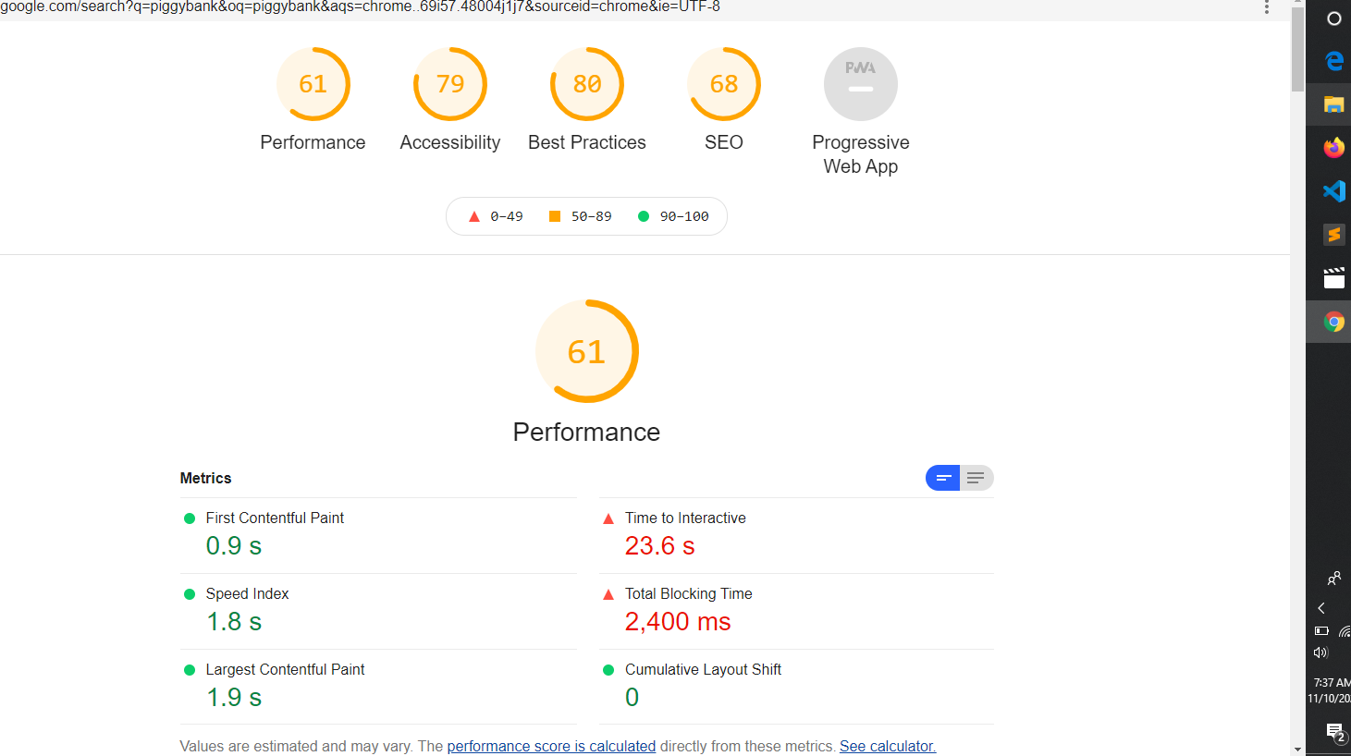

**DIAGNOSTICS FOR PIGGY BANK**

* **low** Images have explicit width and height
* Background and foreground colour are width different constract ratios
* Images have resolution

**3 FOR PUNCH NEWS**

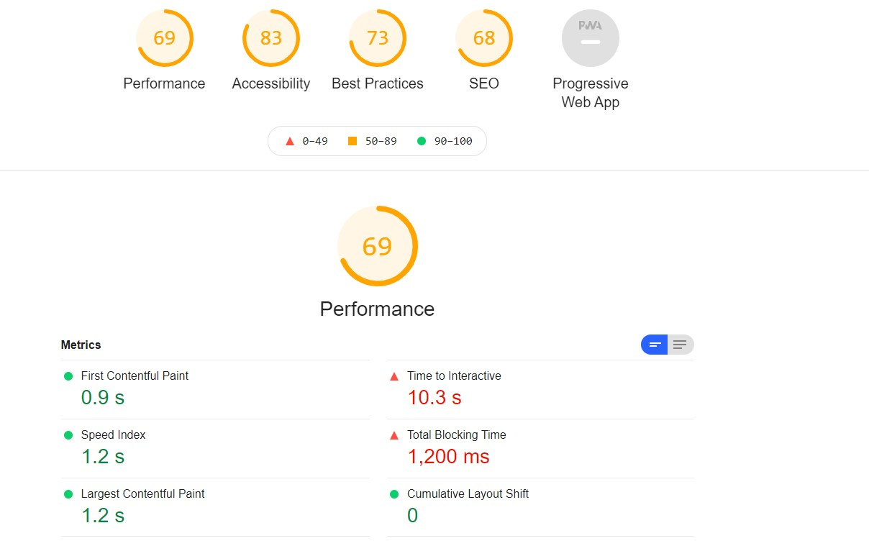

**DIAGNOSTICS FOR PUNCH NEWS**

* Back ground color do not have sufficient constract ratio
* Images are served with low resolution
* Do not use passive listener to improve scrolling performance

**4 FEDERAL GOVERNMENT COLLEGE OGBOMOSO**

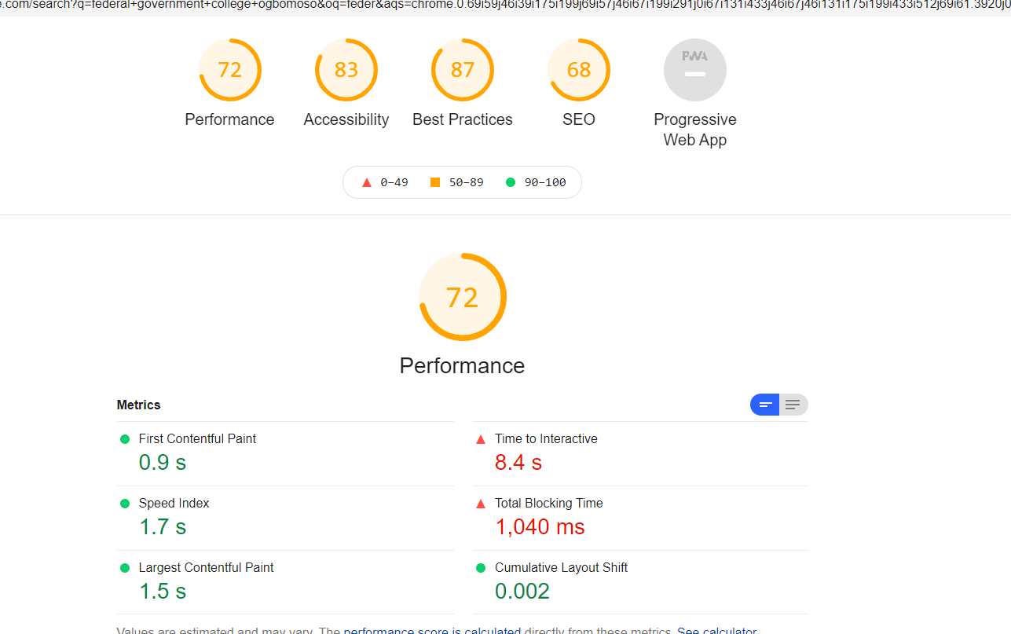**DIAGNOSTICS FOR FEDERAL GOVERNMENT COLLEGE**

* Low speed networking
* Low imageresolution

**5 JUST TOKEN WEBPAGE TEST RESULTS**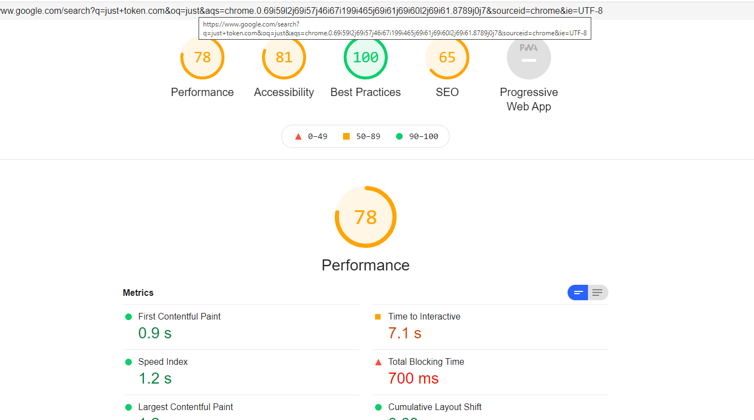

**DIAGNOSTICS FOR JUST TOKEN.COM**

**Their images have low image resolution**

**They have large amout of unused CSS and JAVASCRIPT files**